Cortado Cribbage User Manual

# Game Layout & Components

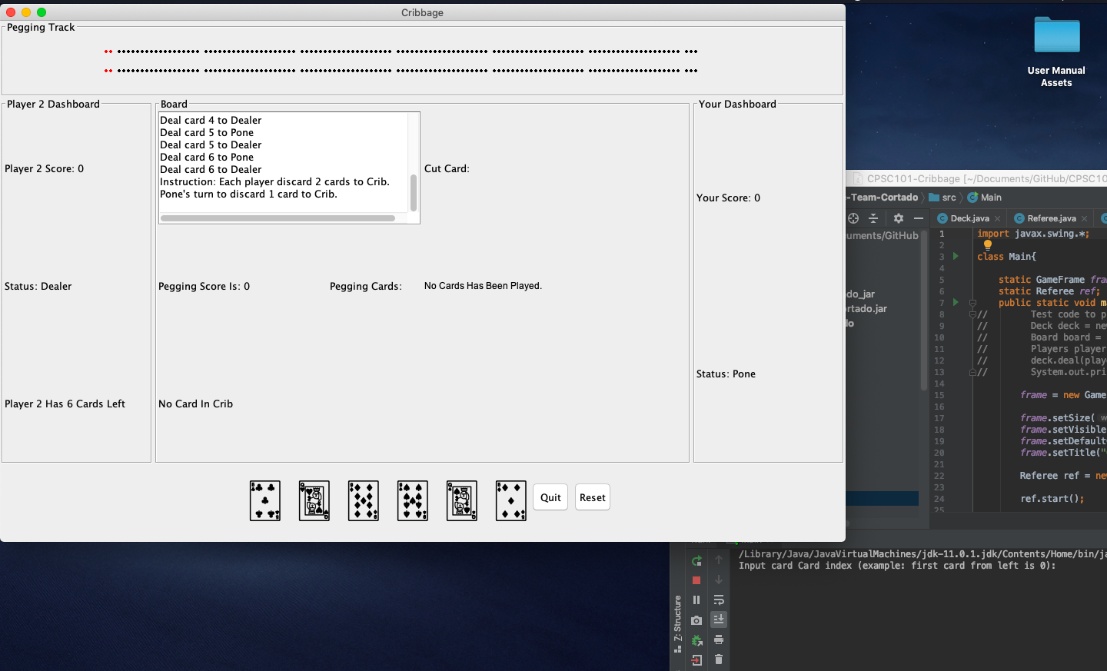

**6. Pegging Display**

**7. Crib**

**1. Track Display**

**5. Your Display**

**3. Game Instructor/Action Display**

**2.Computer Player Display**

**9. Quit & Reset**

**8. Your Hand Display**

**4. Cut Card Display**

**10. User Inputs through console**

1. Track Display:
   * Graphical representation of each player’s score
   * Your score is on the top track
   * Computer Player’s score is on the bottom track
2. Computer Player Display:
   * Contains numerical score of the computer player
   * Whether the computer player is currently the dealer or pone
   * The number of cards left in the computer player’s hand
3. Game Instruction & Action Display
   * Instruction for what to do next
   * Some status update on what just happened in the game
4. Cut Card Display
   * Displays the card cut when it’s drawn
5. Your Stats Display
   * Your numeric score
   * Whether you are the pone or dealer
6. Pegging Display
   * Displays the total card value during the current pegging round
   * Displays the cards that has been played
7. Crib Display
   * Displays the number of cards currently in the crib
8. Your Hand Display
   * Displays the cards in your hand
9. Quit & Reset Buttons
   * Quits the game
   * Reset the game (Currently not working)
10. User Input
    * User inputs card choice by typing in the card index into the console

# How to Play

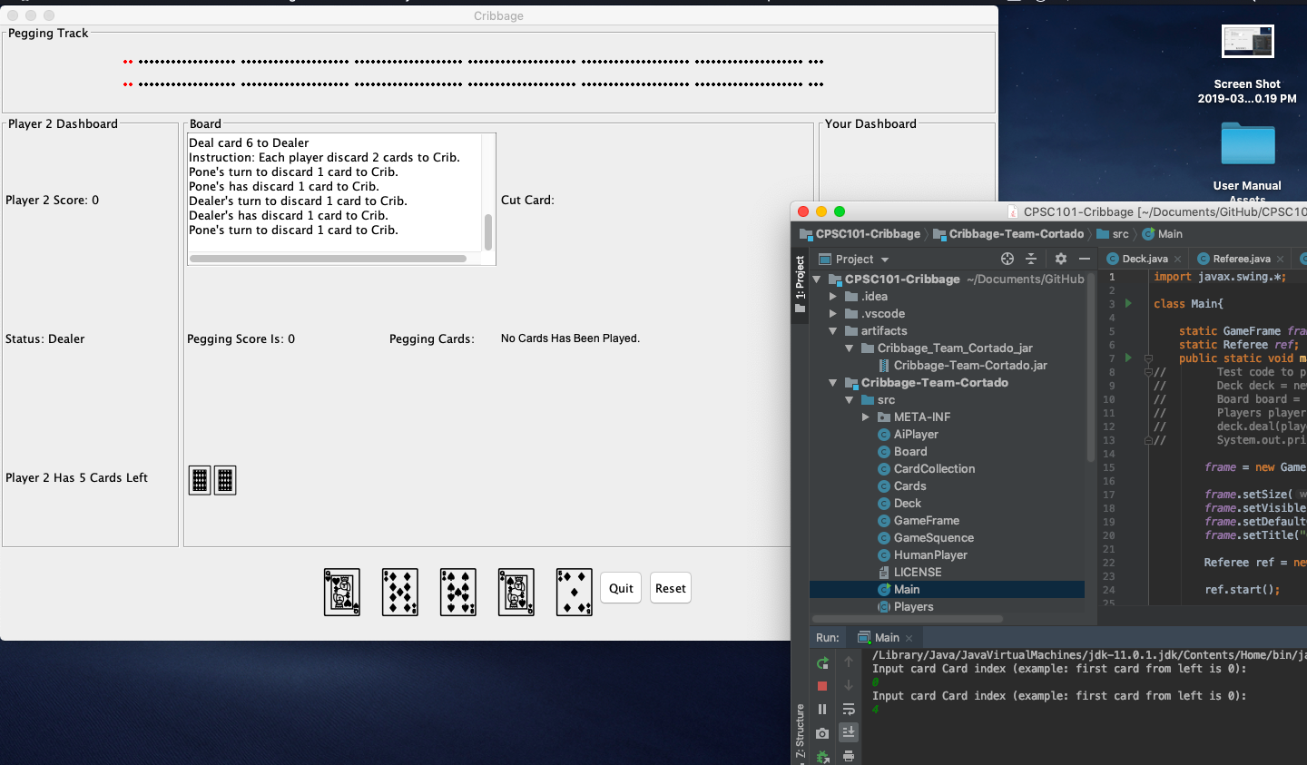

**Enter Input**

* Enter the card index into the console
  + Index starts at 0 for the card on the most left (Queen of heart in the picture above)
  + Index increment by 1 for each of the card to the right, in the picture above 1 would represent the 2nd card from the left (9 of Diamond), and 2 would represent the 3rd card (9 of Heart)

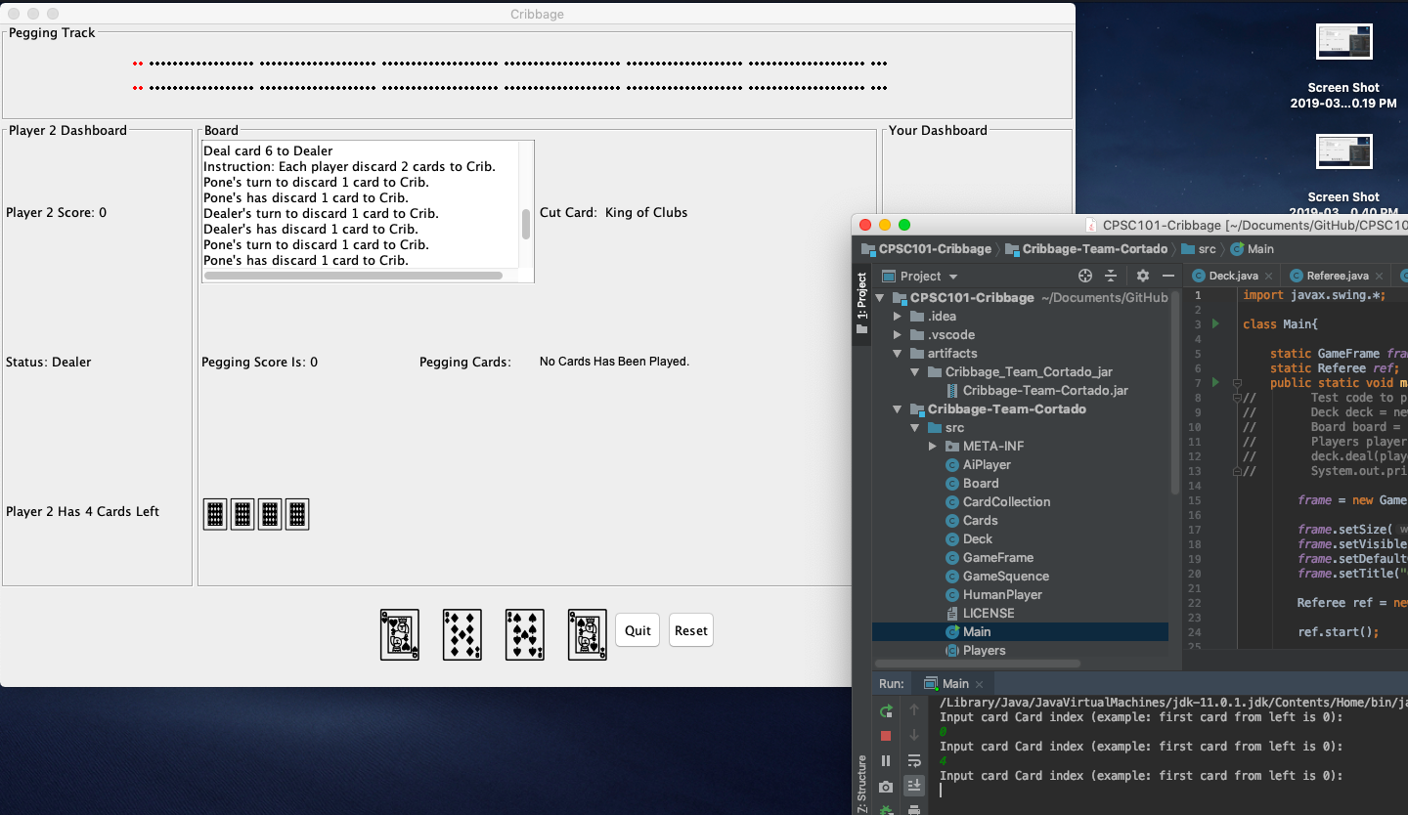

**Instruction**

* To see the game instruction, you will have to manually scroll to the end of the Board

# Known Ways of Breaking the Game

* Typing in String for console input
* Pressing “Reset” button
  + Reset works for only for computer vs. computer at the moment

# Known Bugs

* Scoring not working properly